Notes 3.1: Systems of Equations Name: ______________________

Two variable systems to introduce three variable systems
Solving systems of two linear equations using substitution
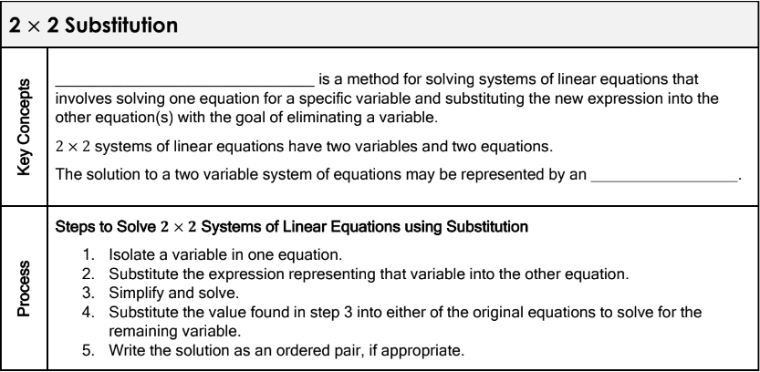

1. $-3x+7y=14$ 2. $x+y=16$ 3. $2b=6a-14$
$2x-y=-13$ $2y=-2x+2$ $3a-b=7$

4. Sam sells athletic shoes part-time at a department store. He can earn either $500 per month plus 4% commission on his total sales, or $400 per month plus a 5% commission on total sales. Write a system of equations to represent this situation and find the total price of the athletic shoes he needs to sell to earn the same income from each pay scale.

Solving systems of linear equations using elimination
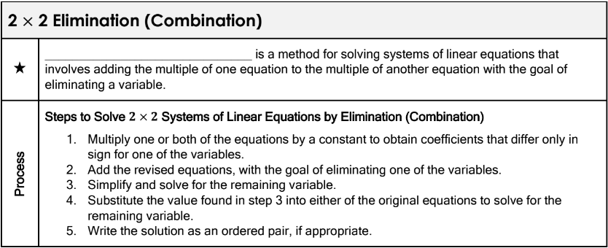

5. $3x-y=10$ 6. $3x+6y=11$ 7. $x-2y=2$
$4x+3y=-4$ $2x+4y=9$ $3x-6y=6$

8. The length of Sally’s garden is 4 meters greater than 3 times the width. The perimeter of her garden is 72 meters. What are the dimensions of Sally’s garden?

